**METAVERSE-VIRTUAL REALITY WITH UNITY**

**PROJECT- Virtual Freedom War Museum**

Relive the Freedom Struggle: Journey Through India's History in Immersive WebVR

TEAM MEMBERS:

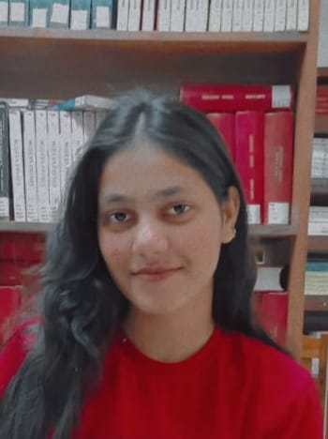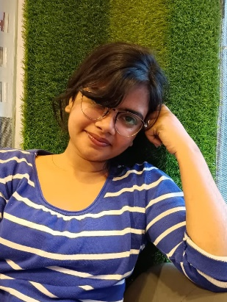

Muskan Gautam Sanjana Bamnawat

B.tech(CSE-AI) 2nd year B.tech(CSE-AI) 2nd year

**CONCEPT:**

The concept is to be creating an immersive experience for people to explore a freedom war museum at the ease of their homes. People can enjoy the visiting a museum without actually visiting one. This project offers 360 degree view and people can get to the remote corners of this virtual museum just by using their cursors.

**Pitch Video:**

https://youtu.be/Bq3Kv4b8xE8?si=626ZsT26tLElwgag

**Project Source code:**

<https://60b8643c-ac64-4b13-ac47-ea38ba4226a1@api.glitch.com/git/ripple-magnificent-script>

**Demo Project video:**

https://youtu.be/ngtUZ2wrwRM